Story box

Using a showbox or any box, create the story of the Baboon on the Moon in a box. Below are examples linked to other stories to give you some ideas.
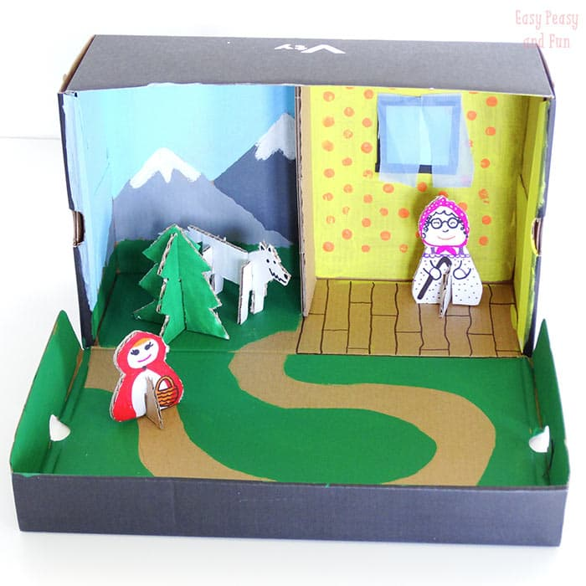
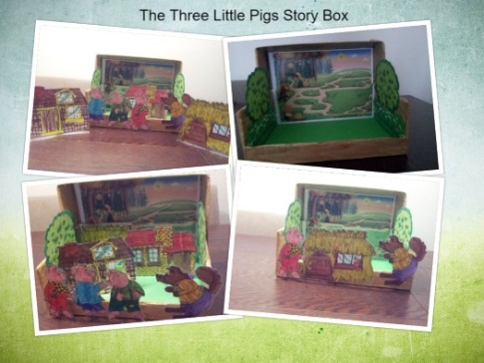
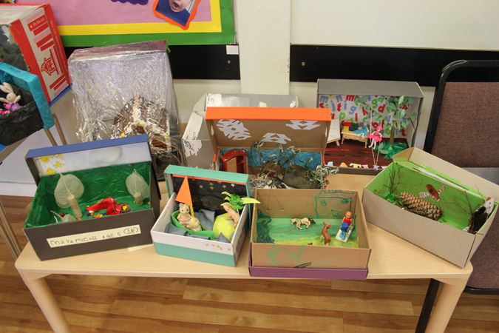

Using resources from your home or even from your garden create the set/scene for the story. Remember to include the key items i.e. baboon, trumpet

This will link with retelling of the story, you can also then act out the new ending of the story.

Good luck! I cant wait to see you photos and videos.

