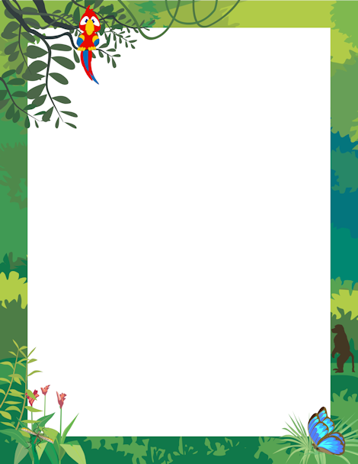

What would the chimpanzees munch?

Who is the king of the jungle?

Who was elephing around?

Who likes to mooch in the mud?

Whose horns touch the sky?

Whose growl makes you tremble with fear?

The leopard’s in his lair – What does this mean?