http://us.cdn3.123rf.com/168nwm/izakowski/izakowski1204/izakowski120400018/13070785-cartoon-illustration-of-a-letter-for-alligator.jpg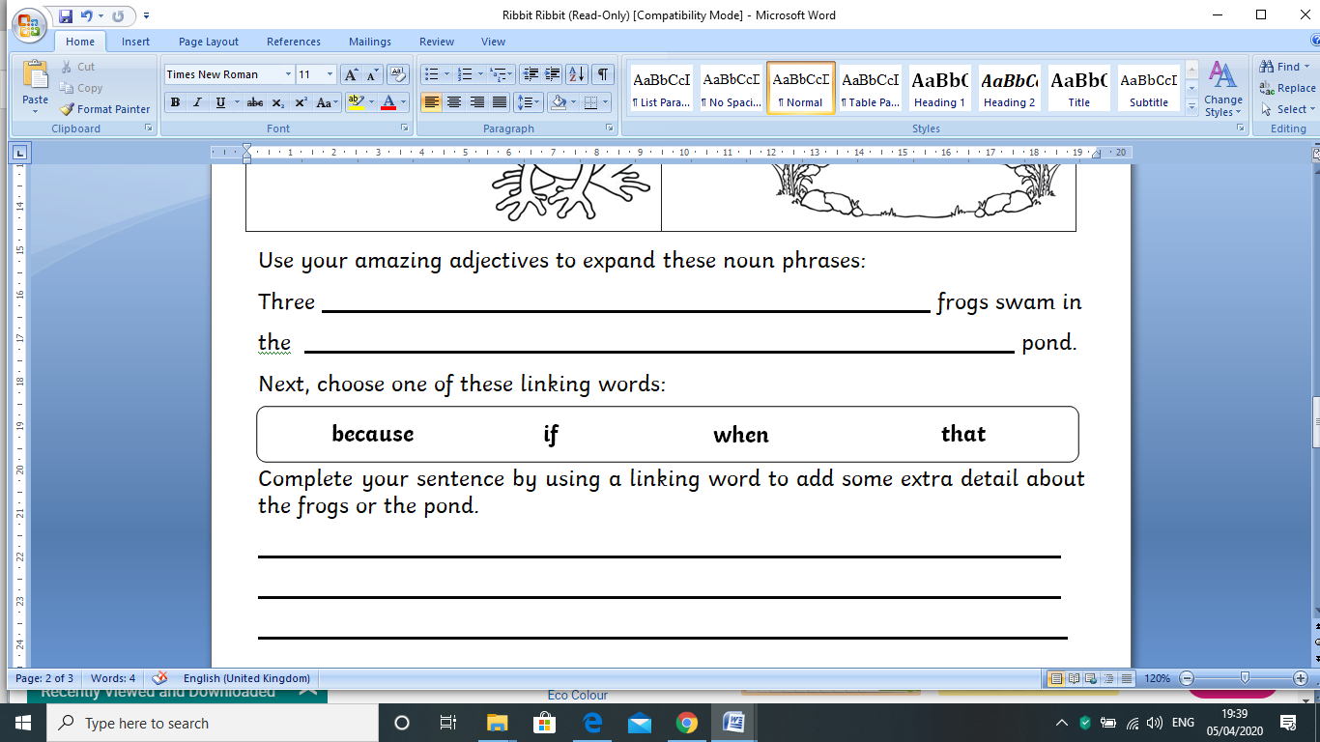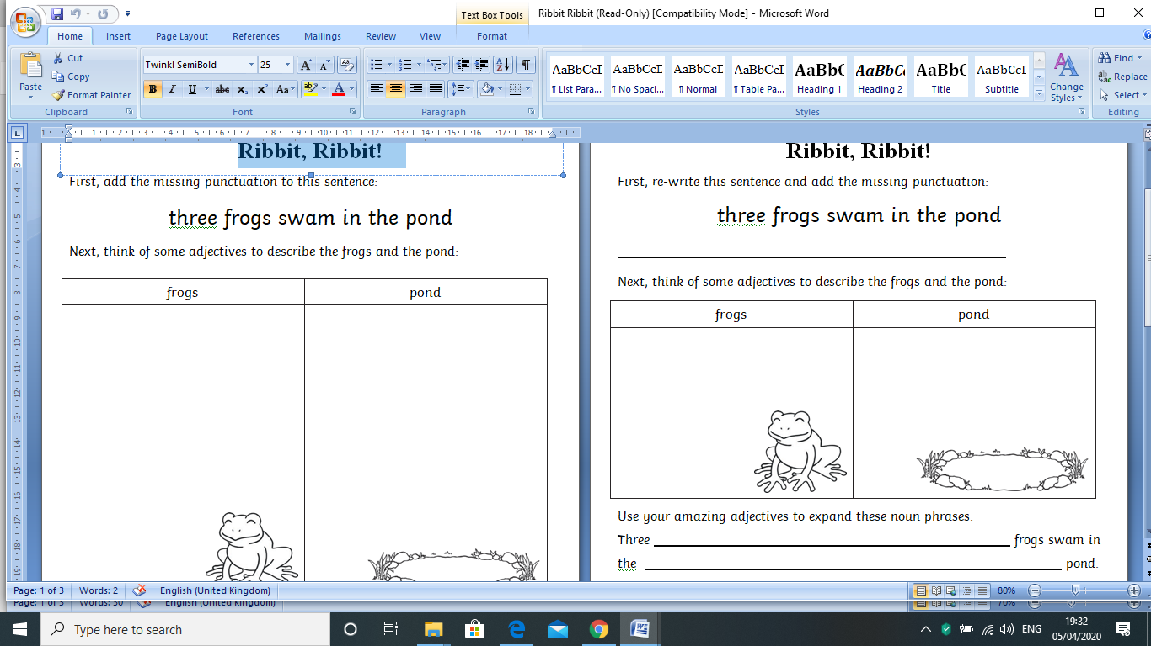

Use your amazing adjectives to add to the sentence:

Three ____________, ____________, ____________ frogs swam in

the ____________, ____________, ____________pond.

Then, complete your sentence, using a word to make your sentence link and add detail to the frogs in the pond.

First, add a capital letter and a full stop to the sentence:

three frogs swam in the pond

Next, think of some adjectives to describe the frogs and the pond: