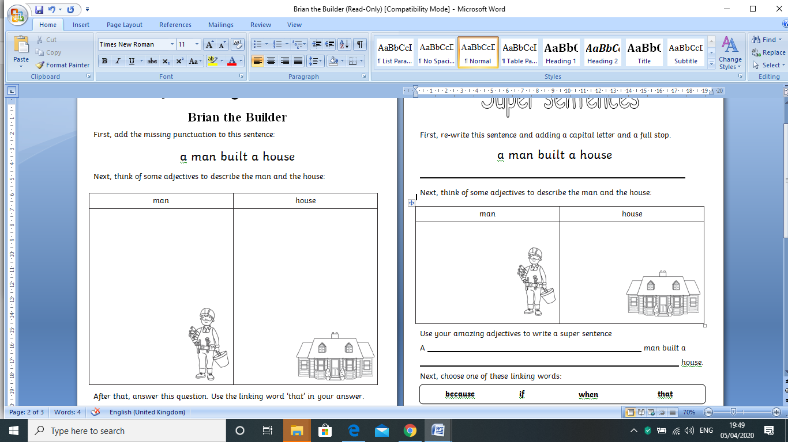http://us.cdn3.123rf.com/168nwm/izakowski/izakowski1204/izakowski120400018/13070785-cartoon-illustration-of-a-letter-for-alligator.jpg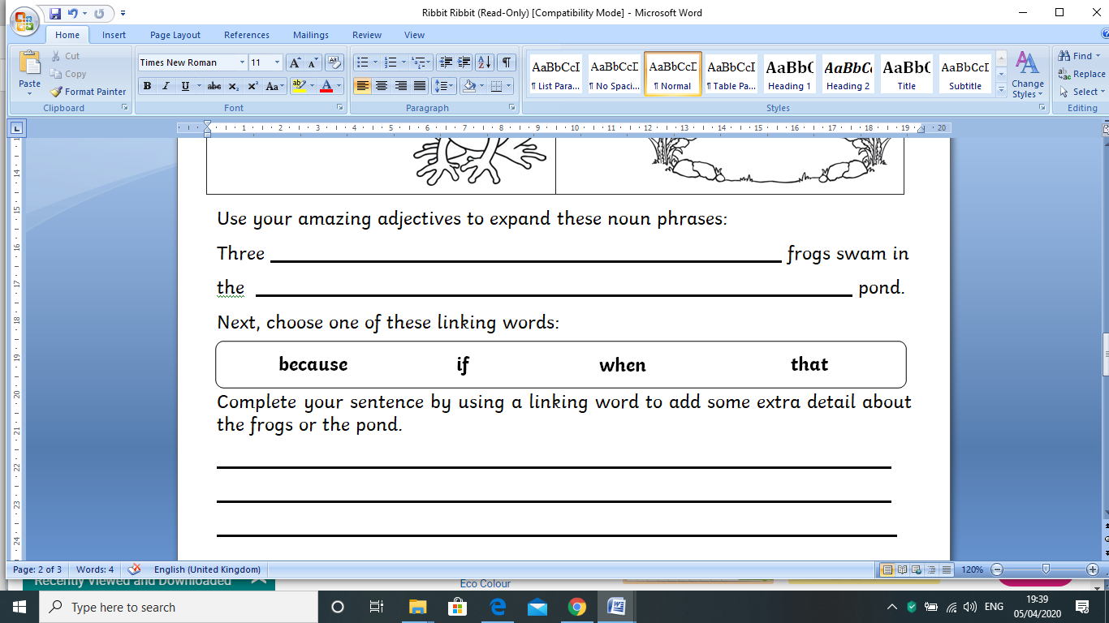

Use your amazing adjectives to add to the sentence:

A ____________, ____________ man built a

____________, ____________, ____________ house.

Then, complete your sentence, using a word to make your sentence link and add detail to the man and the house.

First, add a capital letter and a full stop to the sentence:

a man built a house

Next, think of some adjectives to describe the man and the house: