Name ____________________________ Date __________________
LO: To multiply 4-digit numbers by a 1-digit number using a formal written method.

Use your understanding of multiplication to fill in the missing digits. Challenge 1.

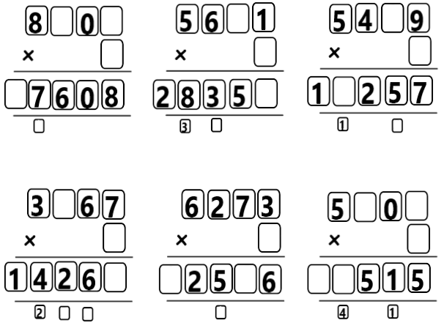

Name ____________________________ Date __________________
LO: To multiply 4-digit numbers by a 1-digit number using a formal written method.

Connectors Challenge 2.
Use a ruler line to connect the multiplications to their correct answers.

