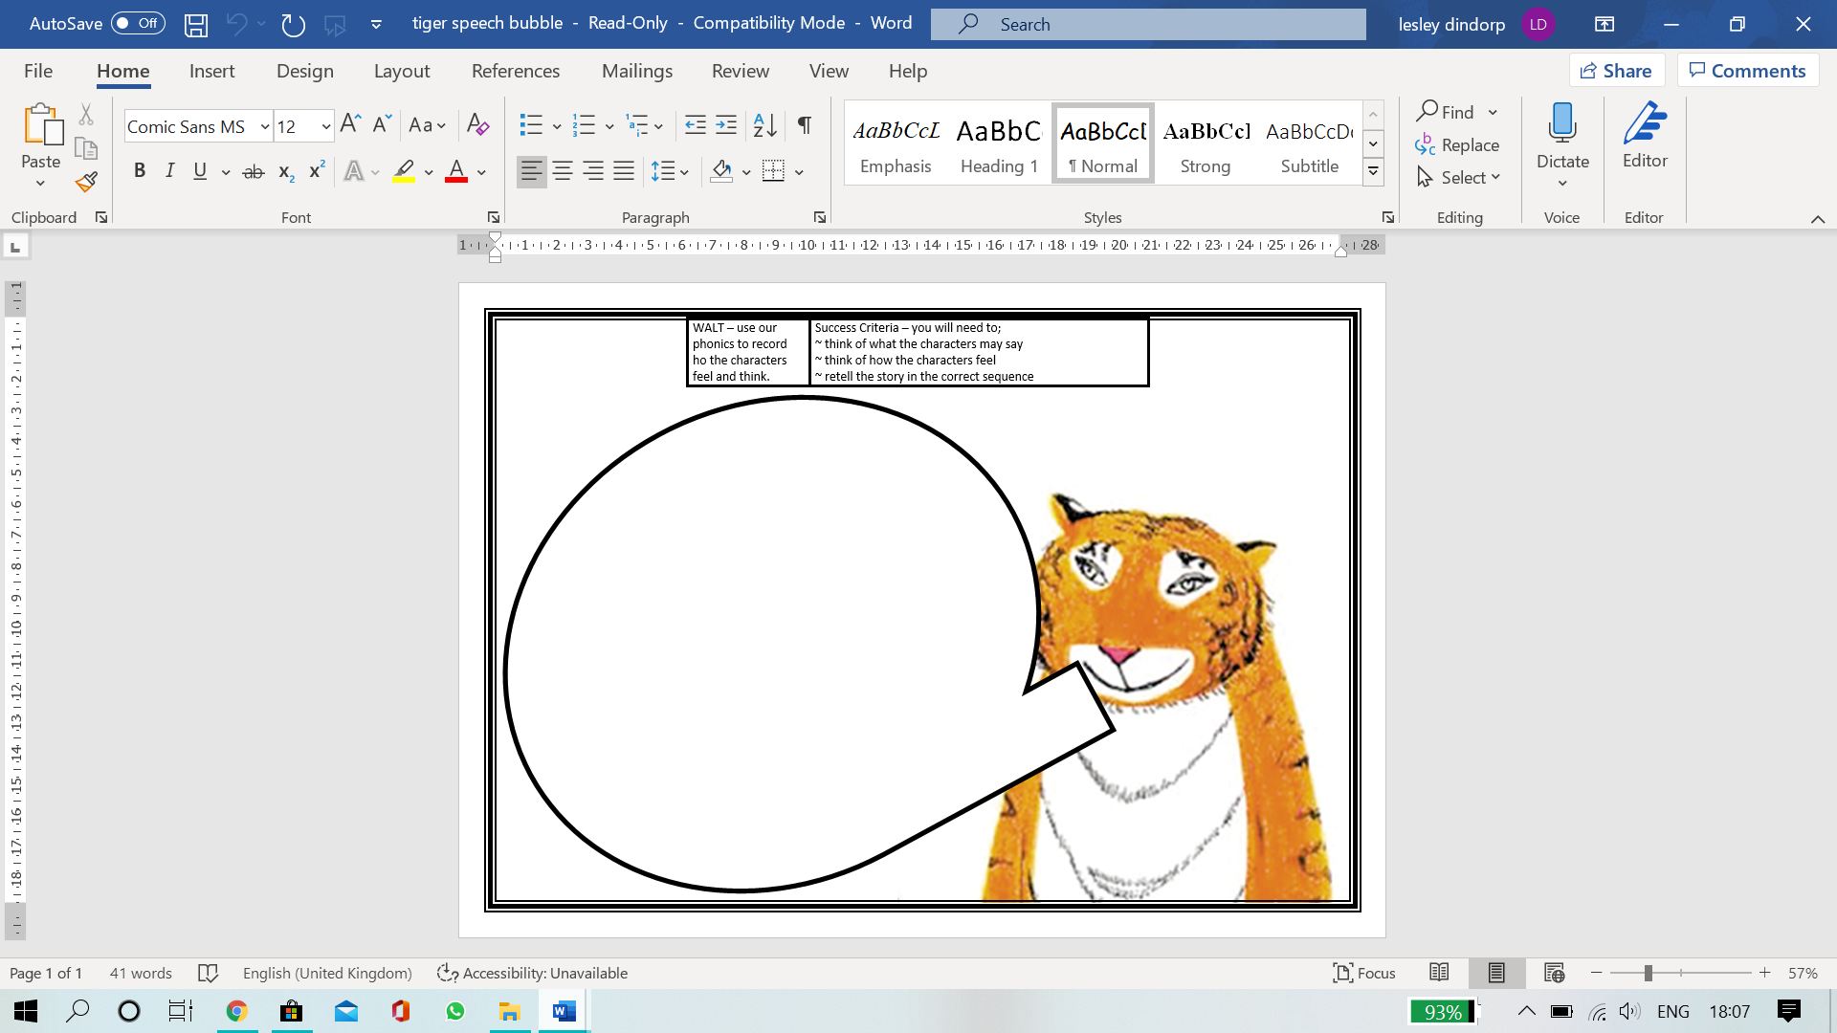

Hello, I am the tiger who came to your house for tea.

I just wanted to say…

Can you think what the tiger would say to family who gave him all their food and drinks? You can ask an adult for help you write what he would say or you can draw a lovely picture from the tiger to say thank you!