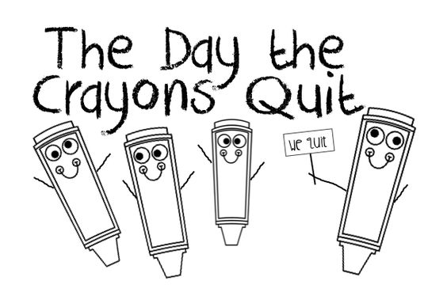
Read the sentences below, fill in the gaps and draw a picture using the correct colour.
1-I am a __________________coloured crayon.
this is a picture of a red ___________________.
2 - I am a __________________coloured crayon.

This is a picture of a blue____________________

.
5 - I am a __________________coloured crayon.

This is a picture of a green_______________________
3 - I am a __________________coloured crayon.

This is a picture of a pink___________________.
4 - I am a __________________coloured crayon.

This is a picture of a Yellow___________________.

