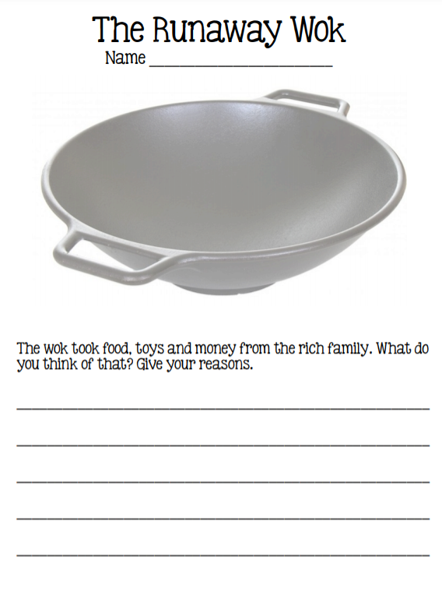

Fill your wok with Chinese food. Get creative!