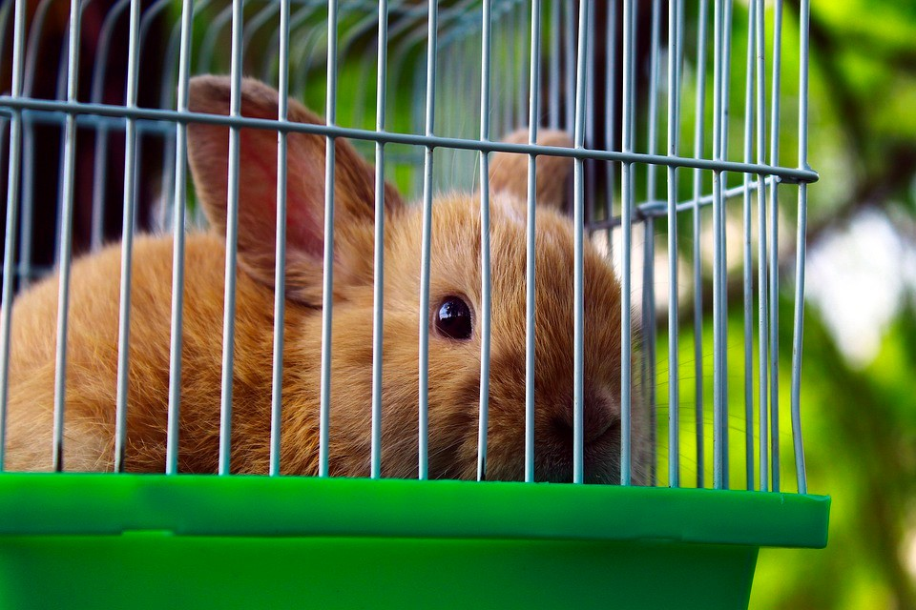
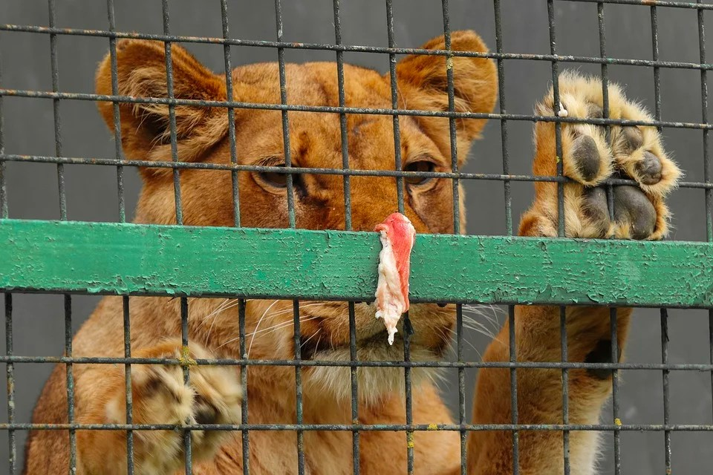
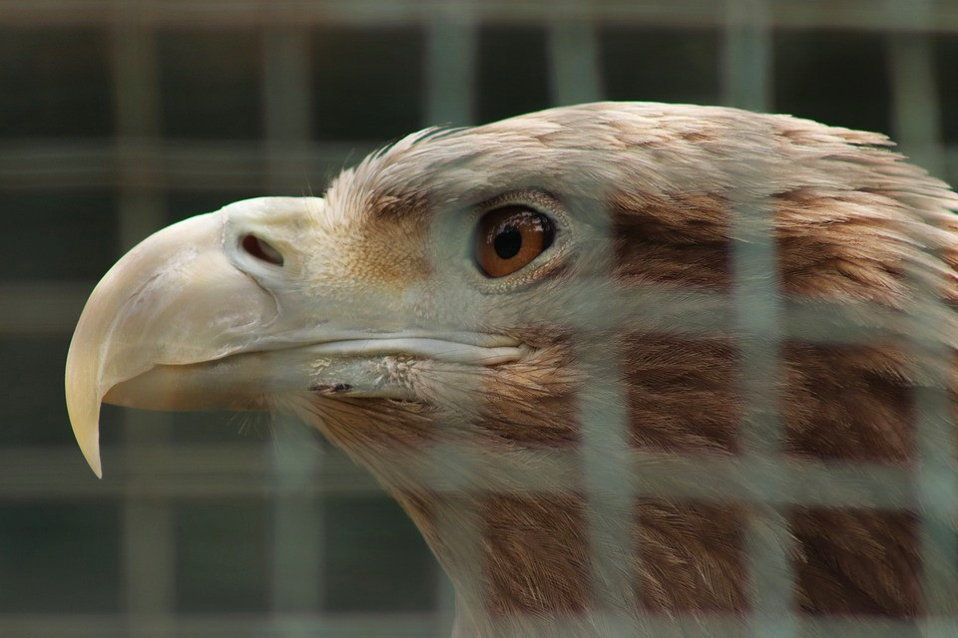
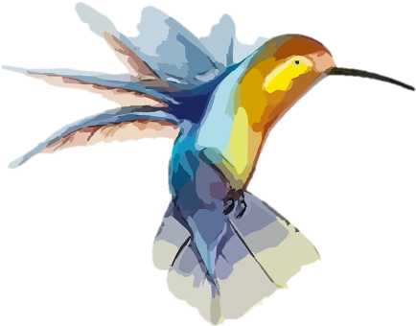
Think carefully about these caged animals. What
might they miss most / desire most about freedom?
Write a sentence for each describing in detail
(
adjectives and adverbs) what they would like to do
if set free.
Choose one animal from the previous page who you would like to set free. Now write a letter to the owner of that animal / zoo persuading them that this animal belongs back in its natural habitat. Below is a snippet from an example persuasive letter (an introduction and first paragraph) to give you an idea about how this might sound. There is also a word bank provided. You may choose to do some research about your animal to help you.
Dear Lakeside Zoo,
It has come to my attention that you are currently housing a lone hippopotamus in your zoo. I believe that this is disastrous for the animal and may set an awful precedent that other zoos decide to follow. I urge you to return the isolated animal to its natural habitat.
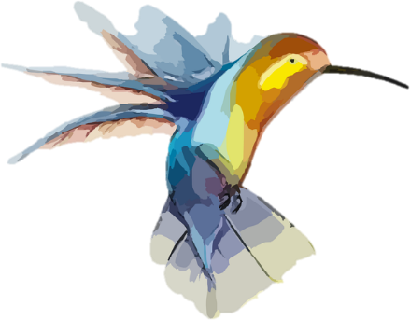
A hippopotamus is an animal whose natural home includes huge expanses of water, mud and a warm climate. You are unable to provide it with any of these things. Hippos are also dependent upon many species of birds (who eat ticks and parasites) and specific African aquatic plants to keep them healthy. Again, these are things that you are not able to supply.
Vocabulary: habitat, natural, healthy, space, environment, captive, exercise, isolated, dependent, necessary, species, climate, diet.
Openers: Firstly, Secondly, Surely,
Furthermore, In addition, For example, For instance, Without a doubt, It is certain that, Finally

My persuasive letter:
___________________________________________
___________________________________________
___________________________________________
___________________________________________
___________________________________________
___________________________________________
___________________________________________
___________________________________________
___________________________________________
___________________________________________
___________________________________________
___________________________________________
___________________________________________
___________________________________________
___________________________________________
___________________________________________
___________________________________________
___________________________________________
___________________________________________
___________________________________________
___________________________________________
___________________________________________
___________________________________________
_________________________________

