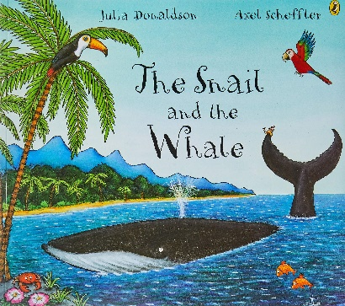
True or false.

Listen to the story and read the statements are they true or false.

The snail lived on a rock as black as soot

The snail wrote 2 “ lift wanted around the world”
Waves splashed the snail onto the whale.

Zig- zag lightening came from the thunderstorm.
There were 20 speedboats in the bay.

The snail said “I feel so small”.

The whale said to get a helicopter to help.

At the school the snail left a message and everyone helped the whale.

The snail and the whale came all the way back to the dock.

