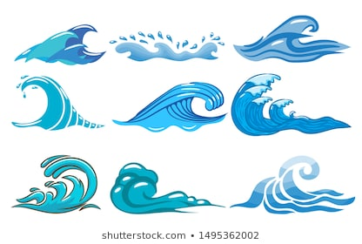Los

**Lost and Found**

The little boy sailed out to sea in a little yellow and red boat. The boy was wearing a little brown and white stripy hat with a pompom on the top. Next to him was a penguin. He was a small, black penguin with a little white tummy. His beak was pointed and orange. Over the waves the boy sailed in his yellow and red boat which looked like an upside down umberella.

Can I listen to the story and draw what I can see?