Here is the link for a short video clip
https://www.literacyshed.com/blackhat.html
Please watch the clip with an adult.
Here are the instructions to follow whilst watching the short clip.

Pause the film after 4 seconds showing the picture of the boy and his grandmother.
- What do we call a child who has no parents?
Pause the film after 11 seconds when the house is shown.
- Do we know any other stories set in a house in the woods?
- What type of stories often include orphans and houses in the woods?
Watch and rewatch up to 32 seconds just before he finds the hat.
- What words does the narrator use to describe the forest?
- What sounds does he hear?
Pause the film after 41 seconds when the boy finds the hat.
- Who do you think this hat may have belonged to?
Pause the film after 1 min 12 seconds when the narrator has described the creatures.
- How do you think the boy is feeling?
- What creatures can we see?
- Can we carefully describe some of the creatures? Pause after 1 min 30 – when the boy is admiring the caged creatures.
- Why has the boy put them in the jars and cages?
- What does he like about the animals?
- Do you think it is right to keep animals locked in cages?
Pause the film after 1 min 49 seconds when only the normal birds came.
- How do you think the boy is feeling now?
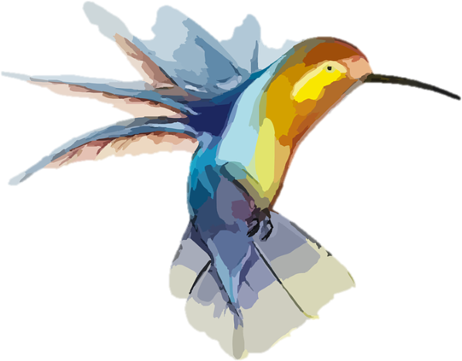
- What other words do we know for sad?
- What things can make us sad?
Pause the film after the boy calls out ‘Please come back to me!’
- What else could the boy say to the bird to persuade him to come back with him?
- What do you think the bird might say back if it could talk?
Pause the film after the narrator says ‘He now knew what he had to do.’
- What do you think the boy is going to do?
- Can we describe the birds as they flew around?
o Can we use a sentence with a verb and an adverb in it? E.g. flying gracefully, swooping beautifully etc. Watch the film until the end.
- Is there a lesson to this story? A moral?
- How should we treat wild creatures?
*Note that there are no answers to these discussion questions

