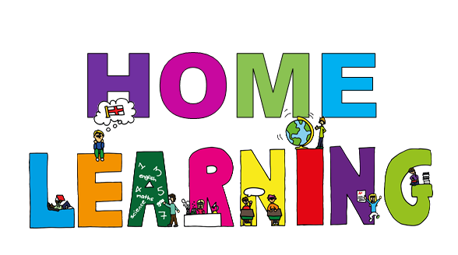
Monday 8th June Dydd LLun 8 Mehefin
Hello everyone! Bore da bawb.

Here are your learning activities to complete for the next two weeks. Most of the activities can be completed using your HWB account using J2e 5 or Microsoft office tools such as power point. Please send completed work to me via email, jamesr100@hwbcymru.net, on twitter tag @penyrheol2 or share using HWB. You can send a picture of your work to me and I can add it to our class page to share your amazing learning.

During the next two weeks we are using a short video as a stimulus. The video
is called ‘Baboon on the Moon’ The video is about a baboon who lives on the moon

https://www.literacyshed.com/baboon.html

Below are a range of activities for you to complete during the next two weeks. You are able to pick and choose (pick a mix grid) what you would like to complete. Feel free to think of your ideas linked to our mini project as well. I would love your ideas to add to our pick a mix grid. I love it when we are all part of your learning and share ideas.

MATHS – there are some maths challenges on the website and activities on mymath.co.uk

Keep a look out on the website for updates during the next two weeks.
Good luck and have fun.
Mrs J
Get writing | Sequence | Story writing | Diary writing
Write a character description of the baboon.  Write a setting description. | Sequence pictures of the story. Use the pictures and sequence the story. | Use your pictures you have sequenced to write a story about the baboon the moon.  You could record yourself retelling the story and acting it out. | Write a diary as if you are the baboon.  https://prezi.com/ui28dijgcobc/diary-writing-ks2/?utm_campaign=share&utm_medium=copy
Design your own set | Postcard | Story ending | Letter writing
Make story box with shoebox or any box, story box sheet and lollipop sticks for the characters. | Write a postcard from the baboon to a friend or family member. | Complete the story, get creative and finish the story.  Read the letter I have included on the website under story ending. | The baboon wants to come home.  Write a letter to the Minister of Moonlight as if you are the baboon asking to come home.  You can think of ideas why he wants to come home i.e. his family/wife/children. He is old.  Get creative and use your imagination.  Remember the features of a letter-  Address sender  Address who sending letter to  Date  Dear  Yours sincerely
Hot seating | Get talking! | Connecting stories
Click the information I have shared on the website.  You could take the role of the baboon and ask a family member to ask you questions.  And/or  A family member could be the baboon and you could ask him questions | Using images from the story write speech bubbles for you think the baboon might be saying.  Then using speech marks right as direct speech. | Find more information and a worksheet on the website.  You are going to compare the video of the baboon on the moon and an advert called the man on the moon.
Review time!
- Write a film review about the video clip you have seen. Template on the class page. Think about good/bad points. Star rating etc.
- The film is being turned into a book. Write a blurb for the book. See sheet and information PowerPoint to help on web page.

A blurb is the text on back cover of a book. It is a summary of the story. It aims to get the reader interested in buying or reading the book.

