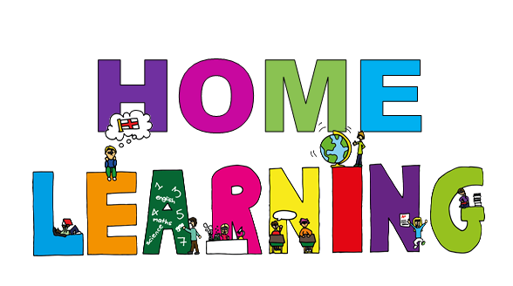

Monday 22nd June Dydd LLun 22 Mehefin
Hello everyone! Bore da bawb.

Here are your learning activities to complete for the next two weeks. Most of the activities can be completed using your HWB account using J2e 5 or Microsoft office tools such as power point. Please send completed work to me via email, jamesr100@hwbcymru.net, on twitter tag @penyrheol2 or share using HWB. You can send a picture of your work to me and I can add it to our class page to share your amazing learning.

- Continue with Baboon on the moon and space work
- Maths – complete my maths challenges
- Reflection time!
This week I would like you to take time to reflect. I would like you to look back over your time at home during lockdown.
Some of you will be returning to school next week for a session a week and some will continue working from home like me. As our lives are changing slightly I thought this was good time to look back together. I would like you to think about how you have felt (feelings), what you have been doing, the good parts/ not so good parts, what you have enjoyed/not enjoyed, have you learnt any new skills etc.
I will share a few sheets on the webpage for you to complete, but feel free to record your reflections in a way that suits you best.

Good luck and have fun.
Mrs James

Activities
Something that made me feel….
I would like you to think about your feelings and record times when you have felt these emotions.

My lockdown diary
Complete the diary (link on webpage), you can choose your favourite day, think of a few days or choose a day this week.

Poem
Write a poem about lockdown, you could write it about how you have felt different feelings/things you have done/what you have enjoyed etc. You can use your name, lockdown, or any word that relates to lockdown for you.

Memory Jar
Complete sheet on website.

Yoga and meditation
Time to relax and unwind
Click the link to enjoy some yoga or meditation (peace out)
Poem – I have given you three examples of different levels – read and choose what type you would like to do. Write your poem about yourself and lockdown.
