Monday 29th June Dydd LLun 29 Mehefin
Hello everyone! Bore da bawb

Here are your learning activities to complete for the next two weeks. Most of the activities can be completed using your HWB account using J2e 5 or Microsoft office tools such as power point. Please send completed work to me via email, jamesr100@hwbcymru.net, on twitter tag @penyrheol2 or share using HWB. You can send a picture of your work to me and I can add it to our class page to share your amazing learning.

This week some of you will be returning to school for a session (good luck and sorry I can’t be there with you all) and some of us (including me ) will continue our learning at home.

This week I have based your learning on the book that Mrs Lecrass will be using in class.

Please complete these activities in order
- Visualisation (sheet on website) of a character from the book
This will involve you reading (or a grown up can read it out for you) a short text and highlight describing words/phrases. You will use this to draw a picture of what you think it will look like.

- Infer (sheet on website)
Look at the front cover – what can you see? What do you think? What can I infer?
record what you think the book will be about, why you think that?
What do you think the character will be like

- Listen to the story, click the link https://www.youtube.com/watch?v=nVuH4BdVQOQ
Read the story (on website)

Now you can choose what you would like to do next. Your activities are linked to the book.

The Bog Baby
- Design your own bog baby. Write about your very own bog baby.
* write keywords around your design
** write a character description for your very own bog baby.
Think about –

- Make you own bog baby/pond in a tray or container.
Watch video https://www.youtube.com/watch?v=yeT52sDtYEU
Useful website http://secondhandsusie.blogspot.com/2017/04/how-i-made-my-washing-up-bowl-pond.html

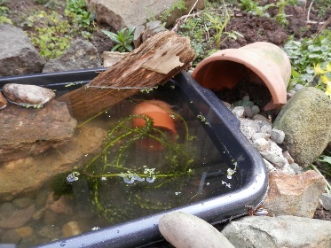
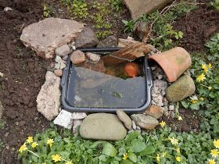

- Write a set of instructions, how to create a pond in a container.
Include:-
Appropriate title.
List of what you will need.
Time order words.
Bullet points/numbered point, list of what you will need
Images

Pond Habitats
- Power point about pond life (on website)
- Research pond life, create a poster/information leaflet about pond life.
Think about what lives in a pond. What do we need to do to look after pond life? Think about animals and plants that live there.

- Watch a video about animals found in a pond https://www.bbc.co.uk/bitesize/clips/z3vs34j
Pond habitat https://www.bbc.co.uk/bitesize/topics/zx882hv/articles/ztf4kqt

- Food chains/webs (see example below)
Use the pond habitat to create food chains (*) or a food web (**)

- Life cycle of a pond animal
You can choose your own. (see below for example) research the life cycle of your chosen pond animal

- Life cycle of blue bells – research the life cycle and then illustrate and write about the life cycle.

- Pond Habitat reading comprehension (on website)
There are three different reading comprehensions to choose from.
Choose *, ** or ***, this allows you to choose your own level of challenge

- Pond power game
Instructions sheet on website

- Use the instructions to make a hopping frog
Information sheet on website

- Water cycle
Watch video about the water cycle https://www.bbc.co.uk/bitesize/topics/zkgg87h/articles/z3wpp39
Click to find out more https://www.twinkl.co.uk/go/resource/tg2-sc-38-the-water-cycle-hotspots
Research the water cycle.
Use images to show the water cycle, remember to label and add key information.
Or you can complete the worksheet (on website) choose your own challenge *, ** or ***

- Branching database
Look at the example below, also there are example on the internet.
Now complete your own. You can complete it using hwb. Click JIT5 then branch, you can add a picture for your background.

- Pond life wordsearch
On website

Art
- Art of ponds
Use the information sheet on the website to get creative.

- Monet, Waterlillies
Research waterlilies by Monet. Use your research and the images to recreate your very own waterlily masterpiece. You can choose your own media, for example (weather permitting) you could use chalk outside.

Good luck and have fun.
Mrs James

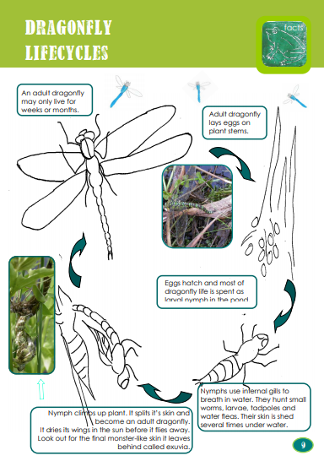
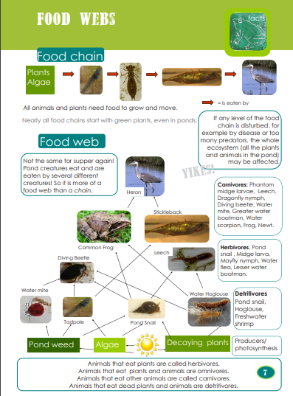

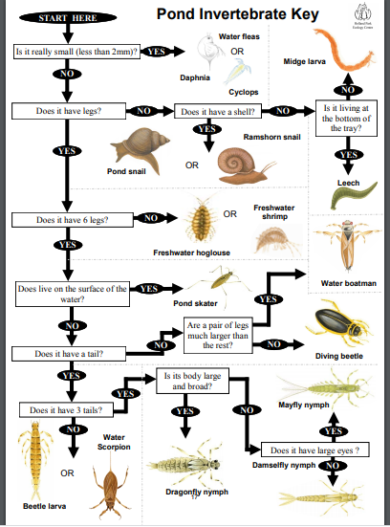
Here is an example

Example of branching key

