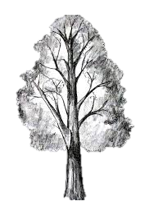

Little Red Riding Hood loves walk through the woods.
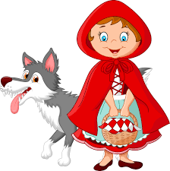
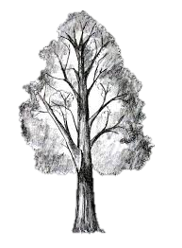
I would like you to either draw or cut out pictures of objects or animals you would see in the woods from a magazine or from the internet and stick them below. One picture for each colour please.

