What is a Percentage?
A percentage, shown by the % symbol, literally means ‘out of 100’.
So for example:
39% means 39 out of 100
96% means 96 out of 100
4% means 4 out of 100
Where are percentages used?
Percentages are most often seen in supermarkets or other shops, advertising a discount.
Examples include:
Sales in shops: That pair of trainers is finally 50% off? Fantastic!
Food labels: Percentages are used to tell you how much a certain food or drink will contribute to your daily calorie allowance.
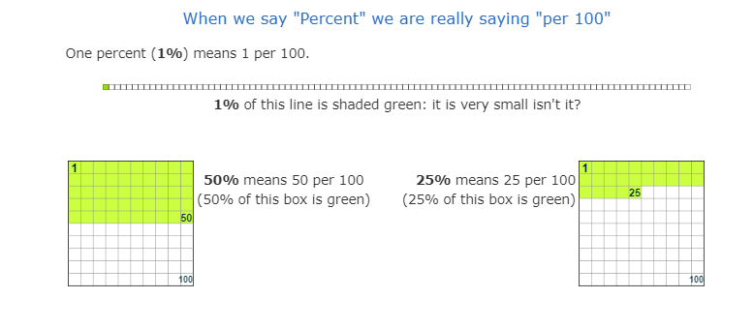
Tax: Taxes are expressed in percentages due to the fact that the things they are being applied to are all different prices.

