Where do I live and what weather do I love?
Sut mae’r tywydd heddiw? What is the weather like today?
Draw a picture of your home below:
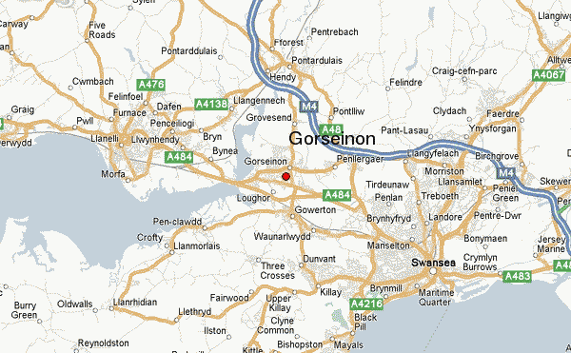

I live in______________.
Mrs Dindorp lives in Dunvant.
I love _____________weather
because ______________________.
She loves warm sunny weather because she can sit in her garden or go to the beach with her family.

