How many adjectives can you think of to describe the season Winter? Write them below

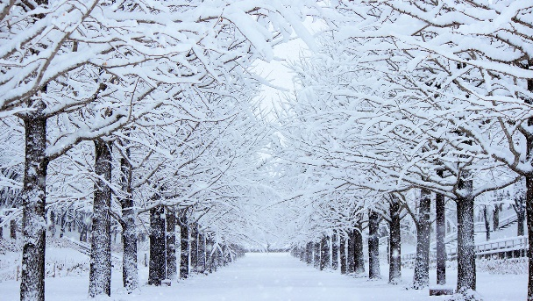
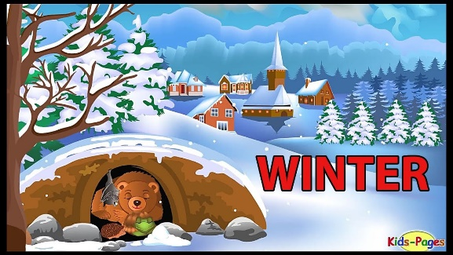

Use these words to write 2 sentences
________________________________________________________________________________________________________________________________________________________________________________________________

