Monday 4th May Dydd LLun 4 Mai
Hello everyone! Bore da bawb.

Here are your learning activities to complete this week. Most of the activities can be completed using your HWB account using J2e 5 or Microsoft office tools such as power point. Please send completed work to me via email, jamesr100@hwbcymru.net, on twitter tag @penyrheol2 or share using HWB. You can send a picture of your work to me and I can add it to our class page to share your amazing learning.

This week your home learning follows on from last weeks project. This week we will look at VE day.
VE Day Project
Below is a range of activities for you to complete during the week. Keep a look out on the website for updates during the week, I will share video links and links to activities and ideas which may help you.
Good luck and have fun.
Mrs J

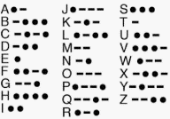
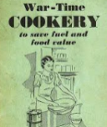
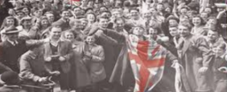
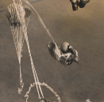
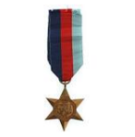
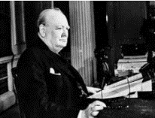
Please continue with your mymaths challenges and reading daily. Also, keep completing activities linked to castle and dragons home learning mat from work 1. Next week your learing will link back to our topic.
I hope you enjoy the activities I have set this week and look forward to seeing all of the wonderful things you get up to. Keep smiling and stay safe. Enjoy the bank holiday celebrating and remember those wonderfully brave people who went to war to protect us and our country!
VE Day Celebrations.
Morse Code was used during the war as a way of sending messages.
Use the information you have been given to crack the Morse Code.

Challenge: can you create your own code and write a secret message for somebody in your family to crack! You could even send it to your teacher!
Many countries were a part of World War II.
Choose a country and create a fact file about this country.
Challenge: You may choose to include current information or information about this country during the war.
Wartime recipe booklet.
Put your maths measuring skills to the test.
In the booklet there are many recipes you could try and make at home with your family.
Challenge: think of your favourite meal – write a recipe card and decorate it for somebody else to enjoy as much as you.
No party is a party without some decorations and this was the case when people held their celebrations at home.
Design and create your own party decorations. They may include: bunting, flags, posters etc.

Challenge: include important facts on your poster/bunting.
During the war parachutes were used by paratroopers, some were even accompanied by dogs.
Design and make your own parachute using materials from around the house. Time how long it takes for your parachute to fall to the floor. You could hold it yourself or even ask an adult to help you drop it from a window.
Challenge: research how parachutes work using the force ‘air resistance’.
Attached is a list of words connected to the war. Discuss these words with your family and talk about their meaning.
Draw an image/write a definition of each word.
Challenge: create a word search or crossword. You may even want to write your own clues for each word.
Medals were given by the British Government to those who participated in World War II.
Design your own medal for a British Soldier to acknowledge their role in the war.
Think about the shape of the medal and color of the ribbon.
Challenge: annotate your medal explaining the decisions you have made and how this relfects the signifance of the war.
At 3pm on Friday 8th May 1945, Winston Churchill (the Prime Minster at the time) made an announcement to say the war in Europe had come to an end.
Practice reading and performing the speech Winston Churchill made on that day – you could even record yourself and send it into school.
Challenge: write your own version of a speech as if you were Winston Churchill at the time.
On VE day street parties took place all over the country to celebrate.
Design a picnic with all of your favourite foods to have at your very own VE Day party. Design decorations to decorate your house
Challenge: Give yourself a budget of £50 and use supermarket websites to calculate the cost of your picnic.
This week all of your learning tasks build up to celebrate the 75th anniversary of VE Day – marking 75 years since the end of WW2. These activities are for you to enjoy as a family leading up to the celebrations being held on Friday 8th May, which is a Bank Holiday..
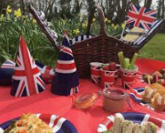
Decoprt

‘Stay At Home’ Street Party  Read this article on Newsround and look closely at the photographs. How did people celebrate in 1945? Plan your own ‘stay at home’ street party.  What games could be played? What decorations would be put up? What food would be eaten? Who would be there? Is there anyone in your family who went to a VE Day party you could speak to?  For something more simple, you could design your own VE Day party invitation or create your own Union Jack flag bunting or make a Union Jack flag out of Lego! | Understanding World War Two/VE Day  On 8th May 1945, Britain celebrated the end of World War Two. To understand why VE Day was so important, you need to understand WW2. Visit these sites to help in your research:  Primary Homework Help - WW2  A Brief Overview of World War II – Video  BBC Teach - VE Day  What Is VE Day?  Can you create a timeline of important events leading up to  VE Day? | Wartime Recipes  With one rationed egg and a packet of powdered milk in the larder, World War II’s home cooks had to be creative. Find out what families were eating over 75 years ago.  Create some delicious meals using the recipe booklets below. You could serve them at your ‘Stay at Home Street Party!’  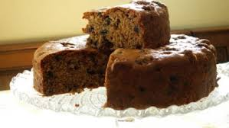  Wartime Recipe Booklet  Wartime Ration Recipes  WW2 Cake  Wartime Scones  Jam Tarts
Crack The Codes  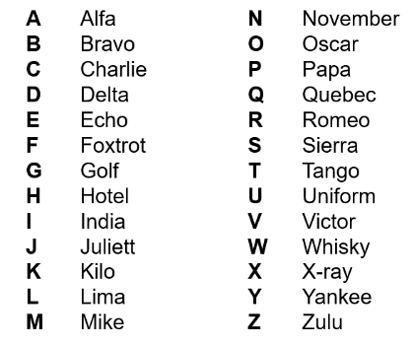  Phonetic Alphabet  The phonetic alphabet that was used in RAF transmissions during the war. Learn to spell your name using the phonetic alphabet e.g.  Ted = Tango Echo Delta  Morse Code  Morse code is a communication system that represents the alphabet and numbers with a series of dots, dashes or a combination of both as shown here. Watch this video to find out more about Morse Code.  Can you write a secret coded message for your family to crack? | VE Day Songs  Try and learn the Horrible Histories VE Day song and perform it to your family.  Create your own motivational song. Listen to some of the following clips for inspiration. Click here to listen to some more traditional war time songs as well as the links below.  Wartime song lyrics  Run, rabbit, run!  Long way to Tipperary/ Pack up your troubles  We’ll meet again  The White Cliffs of Dover  Learn step-by-step how to Swing dance (The Lindy Hop) which originated in the late 1920s and early 1930s in Harlem, New York City. | 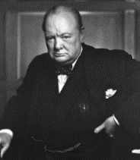  Winston Churchill  Who was Winston Churchill? Why do we remember him today? Produce a fact file/ poster displaying your information.  Create a mind map or list of facts about Winston Churchill.  What was his job?  Why was he so important during WW2?  What was one of his famous phrases?  Can you describe his characteristics?  Why he was important?  You can read more about Churchill using these links from Twinkl and Ducksters. You may present this information in any way you choose or use this template.  CHALLENGE: Can you learn Winston Churchill’s Victory speech and record yourself presenting it?
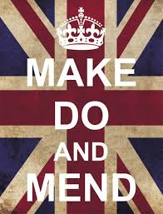  Make, Do and Mend  During WW2, there was a shortage of materials to make clothes. People were urged to "Make, do and mend".  Do you have any clothes or accessories that you could ‘upcycle’ into new clothing or something completely different to give it another purpose and a new lease of life? | Europe during the Second World War  Colour in the countries on the map (here) according to whether they were Allies, Axis, Axis controlled or Neutral.  You could print the map from Twinkl (code UKTWINKLHELPS) or create a list.  NatGeo Kids - WW2 History | Spitfire Science  Design and make your own Spitfire. You could make it out of paper, wood, recycled materials, etc. Test out your design. How far does it glide?  Does the material used for a paper plane affect the distance it travels? Try using newspaper, card, tinfoil, etc and carry out a test. Remember, only change ONE thing to make it a fair test.
Useful websites
https://www.bbc.co.uk/newsround/48201749
https://www.bbc.co.uk/cbbc/watch/horrible-histories-songs-ve-day-song
https://www.bbc.co.uk/teach/ve-day-How-did-the-british-plan-to-celebrate/zndn7nb
https://www.bbc.co.uk/mediacentre/latestnews/2020/75-anniversary-ve-day
https://www.bbc.co.uk/teach/class-clips-video/history-ks2-ve-day/z7xtmfr
https://www.dkfindout.com/uk/history/world-war-ii/ve-day/

