Monday 27th April Dydd LLun 27 Ebrill
Hello everyone! Bore da bawb.

Here are your learning activities to complete this week. Most of the activities can be completed using your HWB account using J2e 5 or Microsoft office tools such as power point. Please send completed work to me via email, jamesr100@hwbcymru.net or share using HWB. You can send a picture of your work to me and I can add it to our class page to share your amazing learning.

This week your homework is slightly different. I would like you to learn about the incredible Captain Tom Moore.
Captain Tom Moore Project
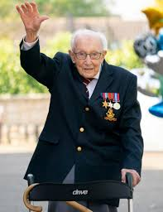
Captain Tom Moore recently completed 100 laps of his garden to raise money for the NHS (National Health Service) Charities. Captain Moore, a solider during World War II, wanted to raise £1000 for the charities. He has achieved greater than this and currently well over 20million. This is an amazing achievement.
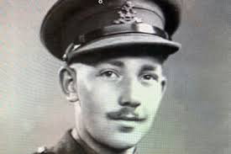
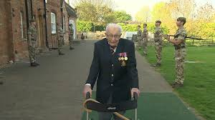

A Happy birthday | A huge thank you | Biography
Captain Moore will be 100 years old on the 30th April.  Design and make him a birthday card.  Send the card to Captain Tom  (please send me a photo first) | Recap our letter writing skills and write a letter to Captain Tom Moore expressing thanks for his tremendous effort.  Explain how his efforts made you and your family feel. | Using your ICT skills research and write a biography/fact file/poster about Captain Tom.  You can use J2e5 or create a power point to show your learning.
Captain Tom Moore, C/O Post Office Limited, 67 Bedford Road, Marston, Moretaine, MK43 0LA, Bedforshire, England
Read all about it! | Get your posh voice on! |  | 10 questions
Recap on your newspaper writing skills to create a newspaper front page report about Captain Toms walk for the NHS  Remember to include all the features of a newspaper. | Record a video thanking Captain Tom for his walk for the NHS. Remember to include your first, where you are from and your thanks.  With adults permission you can share your video on our twitter account. Or share with me and I can do it. |  | Imagine you are lucky enough to meet Captain Tom.  Think of 10 questions you would like to ask him. Think about any aspect of his life.

A work of art | Charity thinking cap | Sing! Sing! Sing!
Create a portrait of Captain Tom. | Think of ways that you could raise money to help a charity. Create a bubble mind map.  Who would you raise money for? Why? | Write a short song thanking Captain Tom  Record yourself and others signing happy birthday to him

Get writing! | Get Singing! Karaoke time!
Write a poem about Captain Tom. Or you could write a poem to send to him. | Captain Tom has been working with Michael Ball and the NHS Voices of Care Choir to record the song You’ll Never Walk alone.  Click the link below to listen to it.  https://www.youtube.com/watch?v=wUP-ty-Tj5E  Learn the song and record yourself and maybe your family singing along.

