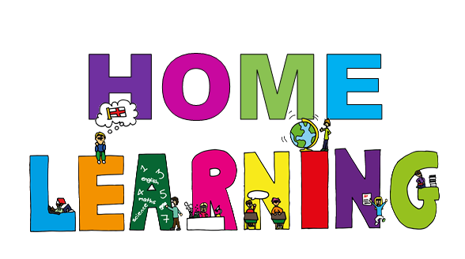
Monday 18th May Dydd LLun 18 Mai
Hello everyone! Bore da bawb.

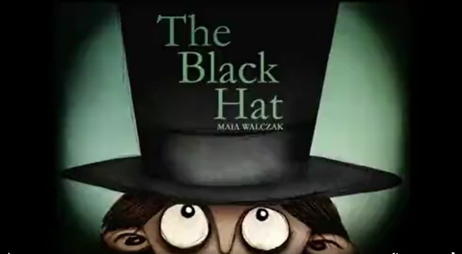
Here are your learning activities to complete for the next two weeks. Most of the activities can be completed using your HWB account using J2e 5 or Microsoft office tools such as power point. Please send completed work to me via email, jamesr100@hwbcymru.net, on twitter tag @penyrheol2 or share using HWB. You can send a picture of your work to me and I can add it to our class page to share your amazing learning.

During the next two weeks we are using a short video as a stimulus. The video
is called ‘The Black Hat’ The video is about a boy who lives with his
Grandmother in an old forest cabin. There wasn’t much for the boy to do
except enjoy long walks in the forest hoping to find something new.

Below are a range of activities for you to complete during the next two weeks. You are able to pick and choose (pick a mix grid) what you would like to complete. Feel free to think of your ideas linked to our mini project as well. I would love your ideas to add to our pick a mix grid. I love it when we are all part of your learning and share ideas.

IMPORTANT
First, watch the clip and follow the instruction sheet.
Then complete the points of view sheet before moving onto the pick a mix grid.

MATHS - I would like you to continue with practising column addition and subtraction. I will share math challenges with you on the website and continue to complete your my maths activities.

Keep a look out on the website for updates during the next two weeks; I will share video links and links to activities and ideas, which may help you.

Good luck and have fun.
Mrs J
Research | Sorting into groups | Bug hunt | Family/friend research
Research what animals you would find in a woodland/forest habitat.  Create a poster/information leaflet to share what you have learnt.  This can be done using HWB or by getting creative. | Sort the animals you have found that live in a woodland/forest habitat into groups using a Venn or Carroll diagram.  Think about the birds, animals and minibeasts that live in a woodland habitat. | There are many mini beasts, which live in the woodland/forest habitat. You also have lots living in your garden too.  I would like you to turn into bug detectives and look what minibeasts you have in your garden.  - Keep a tally  - Record results in a graph ( you can draw a bar graph or use HWB tools (jit5bchart or excel) | Research what is your families/friends favourite minibeast/woodland animal.  This is a good one to keep in touch with family and friends. When you are in touch as them ‘What is your favourite minibeast/woodland animal?  Remember to keep a tally. This time I would like you to use a pie chart to record your results using HWB (chart and choose a pie chart)
Life cycles | Food chains | Make a wormery! | Bird watching!
It is time to look at life cycles. There are many life cycles you could look at which are linked to a woodland/forest habitat.  A life cycle is how a plant or animal has different stages.  For example, you could look at a butterfly or a tree. Alternatively, choose your own; you could do more than one.  You will need to draw pictures and write about each stage of the cycle. Remember to include a title.  You can complete this using HWB tools and by drawing yourself. | A food chain shows how each living thing gets its food.  Look at the video I have shared on the website to help you understand food changes.  Create a food chain for a woodland animal. For example, you could look at a food chain for an owl.  A template is on the class page or draw it out yourself or record on HWB. | Make your very own wormery.  Watch the video on the class page, which tells you how to make a wormery.  Create a set of instructions to make your own wormery. Remember to include a title, pictures a list of what you need, numbers bullet point and time order words. | This can be done as a family. Create a table of birds you see in your garden.  Record a tally chart of what birds visit your garden over the next two weeks.  I wonder if we will all see the same birds or will be see different?  I wonder who will see the most birds?

A work of art | Welsh art | Get writing! | Fact file!
Get creative and draw insects and animals from a woodland habitat.  There are lots of videos on line to help you for example google ‘how to draw a beetle’  Maybe choose your favourite or create an amazing woodland scene. | I have shared a video with you all about how to draw 4 different woodland animals (sorry it is in welsh) it is a step-by-step guide, which you will be able to copy to create amazing animals. By completing this, you will learn the word for the 4 woodland animals in welsh.  It is good fun and easier than it looks. | Write an acrostic poem linked to the woodland habitat. Remember each line starts with a letter of the word you have chosen.  You don’t have to write an acrostic poem, you could write a general poem. It could rhyme.  You choose. | Create a fact file about your favourite animal/minibeast in the woodland. Research information about a chosen animal. Remember to make it eye catching and include pictures.  I will put examples and templates on the class page for you.
Branching Keys! | Get writing! | Get creative! | Story writing!
A branching database/ classification key is when you ask a series of questions to identify a given animal.  Watch the video. Look at the examples I have shared with you on the class page.  Create your own by thinking of questions. You can use HWB- JIT 5 then branching to complete it or draw your own. | Write a description of the boy’s home in the wood.  Think about what it looks like? What sounds can be heard? Is it dark?  Remember to use amazing describing words. | Design and draw a magic hat with a different power.  What magic power will it have? What will it look like?  Use your imagination and get creative.  Draw and label your hat. | Write a story about one of your own items (from the mysterious shop) being purchased and what happens next.

Inventing time! | Symmetry! | Word search. | Thinking hats!
Imagine that you are returning to his house, the boy discovers another magical creature in his bedside drawer. What could it be?  Design your own animal/ minibeast for a woodland habitat.  Think about  What type of creature could it be? Could it be a combination of two or more different creatures? What it will look like? What colour and pattern could it have? Where will it live? What will it eat? How does it move? What noise does it make?  Draw a detailed picture and label to explain the features and answer the questions above. Make sure you use adjectives in your labels.  Take it one-step further and write an information text about the animal. | Complete the sheet I have shared with you on the website.  How about creating your own for a family member to complete. Or send it to a friend for them to complete.  I have shared square paper for you to print if you would like to.  Or could use items in nature or around your house to complete this activity.  Remember to take a photo if you use actual objects. | Complete the word search I have shared on the class page.  What is an adjective?  What is a verb?  Create your own word search linked to our mini project.  Can you include adjectives and verbs? | Complete the worksheet I have shared on the class page under thinking hats.  Once you have completed the first page you will then write a persuasive letter.  This is recapping on a style of writing we have used. We used persuasive writing to write a letter about plastic pollution.  Remember to include all the features
 | Imagination time! | Geometric bird!! | Review time!!
 | Complete the worksheet on class page | See class page on website for sheet.  This links to work we have done about shapes. | - Write a film review about the video clip you have seen. Template on the class page. Think about good/bad points. Star rating etc.  - The film is being turned into a book. Write a blurb for the book. See sheet and information PowerPoint to help on web page.  A blurb is the text on back cover of a book. It is a summary of the story. It aims to get the reader interested in buying or reading the book.

Useful and helpful websites.

WELSH ART
https://www.youtube.com/watch?v=Ikf710GEiPI&feature=youtu.be

FOOD CHAIN
https://www.bbc.co.uk/bitesize/topics/zbnnb9q/articles/zwbtxsg
https://www.bbc.co.uk/bitesize/topics/zbnnb9q/articles/zsphrwx
http://www.crickweb.co.uk/ks2science.html

LIFE CYCLES
https://www.bbc.co.uk/bitesize/clips/zt96sg8

Butterfly lifecycle
https://www.youtube.com/watch?v=3o_nE1X014U
https://www.youtube.com/watch?v=wz6Uz46k2gQ
https://www.natgeokids.com/uk/discover/animals/insects/butterfly-life-cycle/
https://www.dkfindout.com/uk/animals-and-nature/insects/butterfly-life-cycle/

CLASSIFICATION/BRANCHING DTATBASE
https://www.bbc.co.uk/bitesize/topics/zxjj6sg/articles/z9cbcwx

SORTING INTO GROUPS
https://www.bbc.co.uk/bitesize/topics/zn22pv4/articles/z3nbcwx

WORMERY
https://www.youtube.com/watch?v=uJz6eXs2yzg

FUN GAMES LINKED TO MINI PROJECT
https://www.topmarks.co.uk/search.aspx?q=minibeast

INTERESTING INFORMATION
https://www.bbc.co.uk/bitesize/topics/z6wwxnb

Writing a Blurb
https://www.youtube.com/watch?v=rhqMj5q5qag

