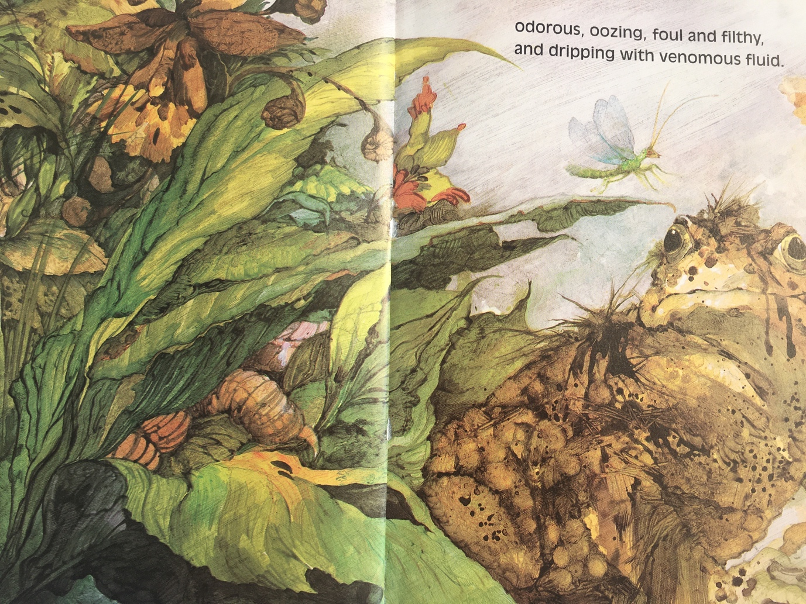

Find as many words as you can that mean the same as filthy.

Find 3 words that rhyme with foul.

