Word Search
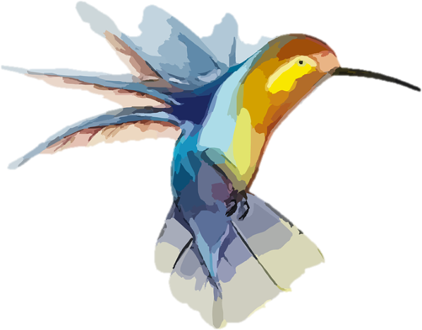
Can you find the following words in the word search? Words can read forwards, backwards, up, down, diagonally and can intersect.
e | c | s | l | u | f | e | c | a | r | g | g
a | o | e | e | d | o | p | e | t | a | c | s
l | l | d | t | o | d | i | v | e | r | w | e
e | o | e | a | w | p | a | t | s | o | f | l
d | u | p | c | s | p | r | e | o | n | v | u
e | r | p | i | e | e | o | p | b | g | a | f
l | f | a | l | t | h | g | i | r | b | n | i
a | u | r | e | t | n | w | o | p | e | r | t
e | l | t | d | a | g | o | o | p | d | o | u
s | c | i | e | t | a | r | o | b | a | l | e
o | r | n | a | t | e | c | o | l | o | u | b
d | e | l | e | g | n | u | l | p | i | r | b
adjectives: colourful, delicate, ornate, elaborate, bright, graceful, beautiful,
verbs: swoop, dive, plunge, trapped, sealed

