Year 4 half Term Home Learning

Thank you to everyone for your home learning support so far this year.

Spending quality time with family is the main priority for the half term break but if you do have some free time, we ask you to support your child’s learning at home in the following ways:

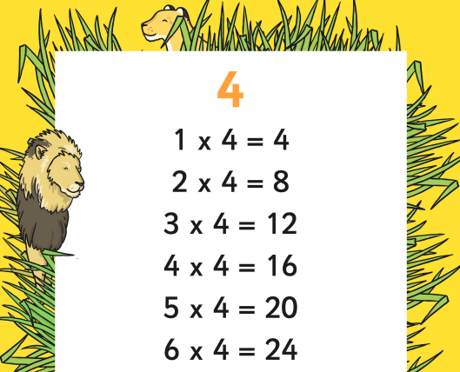
Maths: We have been busy mastering the three times table and daily practise has improved our speed at recalling them when multiplying and dividing. The attached sheet will help your child to learn their four times table.
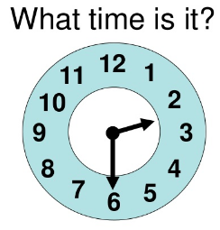
Our next topic in maths will be ‘Time’. Please practise telling the time with your child using both analogue and digital clocks.

We will continue to set short tasks via www.mymaths.co.uk Please help your child to access this website.

www.topmarks.co.uk is a fantastic website with a range of maths games. Use the search box to find time games or try some of these:
https://mathsframe.co.uk/en/resources/resource/116/telling-the-time
http://flash.topmarks.co.uk/5262
https://www.topmarks.co.uk/Flash.aspx?f=matchingpairstimev3

Literacy: Please try exploring our home reading website www.oxfordowl.co.uk

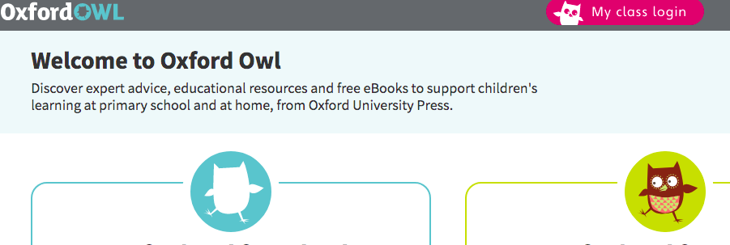
Go to my class login and use the following details to login:
Username: missshackley
Password: missshackley

There is an extensive range of books available to read. Please work with your child to choose a book that they are interested in and that is a suitable reading level.
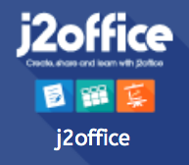
ICT: The children have loved learning how to create presentations using ‘Present’. This is one of the tools available in J2E (its very similar to PowerPoint) Can you create your own presentation using ‘Present’? You could choose your own topic or use one of the following themes:

- How to keep your heart healthy
- What is Autumn?
- All about me

As a class, we will share and discuss our home learning efforts with plenty of merits!
Have a safe and relaxing half term.
Miss Shackley and Mrs Rabey

